EXPERIMENT 18 — HIGH LEVEL LANGUAGE EXTENSION WITH CURSORS
AIM
To implement Cursors using program in MySQL.
Create employee table
DROP TABLE IF EXISTS employees;

CREATE TABLE employees (
id INT,
name VARCHAR(100),
email VARCHAR(100)
);

Insert employee data
INSERT INTO employees VALUES
(1, 'Harry Potter', 'pharry@warnerbros.com'),
(2, 'Clark Kent', 'kclark@dccomics.com'),
(3, 'Tony Stark', 'stony@marvel.com');

Create the cursor procedure:
DROP PROCEDURE IF EXISTS build_email_list;

DELIMITER $$

CREATE PROCEDURE build_email_list(INOUT email_list VARCHAR(4000))
BEGIN
DECLARE v_finished INT DEFAULT 0;
DECLARE v_email VARCHAR(100) DEFAULT '';

DECLARE email_cursor CURSOR FOR
SELECT email FROM employees;

DECLARE CONTINUE HANDLER FOR NOT FOUND
SET v_finished = 1;

OPEN email_cursor;

get_email: LOOP
FETCH email_cursor INTO v_email;

IF v_finished = 1 THEN
LEAVE get_email;
END IF;

SET email_list = CONCAT(v_email, ';', email_list);
END LOOP get_email;

CLOSE email_cursor;
END $$

DELIMITER ;
Run the procedure
SET @email_list = '';

CALL build_email_list(@email_list);

Display the email list
SELECT @email_list AS email_list;
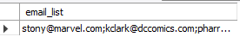
Check employee table
SELECT * FROM employees;
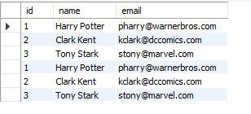

RESULT
Thus the Cursor program using MySQL was executed successfully.

